|  |  |
| --- | --- |
| **RESILIENCE being ready, willing and able to LOCK ON TO LEARNING** | **RESOURCEFULNESS being ready, willing and able to LEARN IN DIFFERENT WAYS** |
| **Absorption Learning Muscle;** you become engrossed in what you are doing; you are unaware of time passing  **Managing Distraction Learning Muscle;** you know what distracts you, you try to minimise distractions, you settle back quickly after an interruption  **Noticing Learning Muscle;** you notice how things look, what they are made of, or how they behave, you can identify significant detail  **Perseverance Learning Muscle;** you are not put off by being stuck, you keep on going despite difficulties and find ways to overcome them, you recognise that learning can be a struggle | **Questioning Learning Muscle;** you are curious about things and people, you often wonder why, you play with ideas, asking "How come?" and "What if?"  **Making Links Learning Muscle;** you look for connections between experiences or ideas, you find pleasure in seeing how things fit together, you make patterns  **Imagining Learning Muscle**; you picture how things might look, sound, feel, be; you let your mind explore and play with possibilities and ideas  **Reasoning Learning Muscle;** you create logical arguments, you deduce what might happen, you look for evidence |
| **REFLECTIVENESS being ready, willing and able to become MORE STRATEGIC ABOUT LEARNING** | **RECIPROCITY being ready, willing and able to LEARN ALONE AND WITH OTHERS** |
| **Planning Learning Muscle;**you think about what you want to get out of learning, you plan the steps you might take, you access which resources you may need  **Revising Learning Muscle;** you are ready to revise your plans as you go along, monitor how things are going, change your plans when you've had a better idea  **Distilling Learning Muscle;** you mull over experiences, draw out useful lessons from experiences, think about where else you might use these lessons  **Meta-Learning Muscle;** you are interested in how you learn as an individual, know your strengths and weaknesses as a learner, are interested in becoming a better learner | **Interdependence Learning Muscle;** you know how much interaction you need with others to assist your learning, you make informed choices about working on your own or with others  **Collaboration Learning Muscle;**you manage your feelings when working with others, you understand the ground rules of team work, you are able to work effectively as part of a pair or team  **Empathy and Listening Learning Muscle;** you put yourself in other people's shoes to see the world from their point of view, show you are listening by eye contact and body language, hear feelings and thoughts behind someone's words **Imitation Learning Muscle;**you are ready to learn from others, notice the approach and detail of how others do things |

**Why BLP?**

**Building Learning Power is an approach to learning to learn.**

We can continually develop our capacity to learn throughout our lives. Guy Claxton who has created Building Learning Power suggests that there are 4 key learning dispositions;

**Resilience < Resourcefulness < Reflectiveness < Reciprocity  
…THE 4 R’s**

These dispositions are inherent in us all. They are not fixed at birth, or when we leave school; they can be developed by everyone regardless of “ability”, social background or age. In fact, **there are NO limits to extending our learning power!**  
  
We can think of these dispositions as being like groups of "learning muscles". Just as we can build our physical muscles with the right kinds of exercise, so we can exercise our learning muscles to develop their strength and stamina. Each of these dispositions is made up of a number of learning behaviours, which are called capacities. Because the learning capacities are quite specific in nature, they can be individually trained, nurtured and exercised.   
  
**Have you exercised your learning muscles today?**  
Because if these learning muscles are not exercised, through lack of opportunity or encouragement, they can so easily wither and fall into disuse.

**LET'S START PUMPING THOSE MUSCLES**  
  
 **BLP tips for Managing Distractions**  
Homework can be a challenge for learners small and big! Discuss/consider what learning environment might be appropriate for your child at home. Think about internal distractions, such as hunger, tiredness, emotions, failure and put strategies/schedules into place to overcome these barriers. Give them time to talk about situations that are bothering them and allow them time to deal with emotions before settling to a task. Depending on the age of your child talk about what you do to manage your distractions. A refreshment break? Music on or off? Physical activity? A change of room? Breathing exercises?

**Remember:** Brain breaks are great if you get stuck or lose focus.

**Characters and Language**

Our whole school ethos is one of being self-motivated and taking a personal responsibility.  
All staff have high expectations of learners, believing that everyone has something to offer and the capability of rising to a challenge.  
We reinforce this by encouraging learners to reflect on how and why a success, however small or large, has been achieved.

**Positive role models**  
Teachers and TAs model learning themselves. They share their own difficulties, frustrations and triumphs in learning. They admit they don’t know the answers to some of the questions asked of them and pursue new knowledge alongside their pupils. They display being a vulnerable learner. They model how to respond to others doing things well and how to use mistakes as a springboard for new learning.   
  
**Language for Learning**  
Language for learning is used in all classrooms, across the school. This helps everyone to talk about and understand learning to learn.

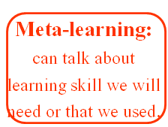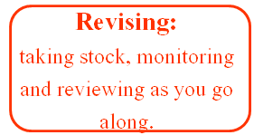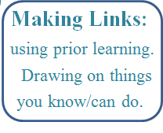 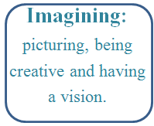

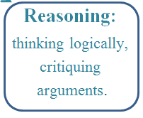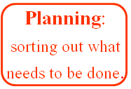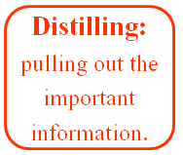

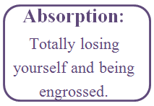

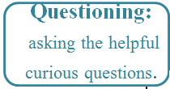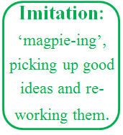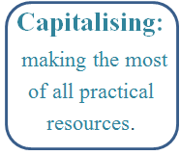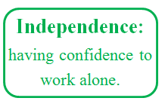

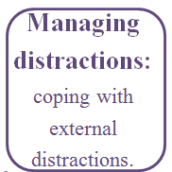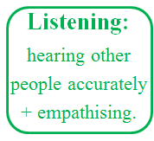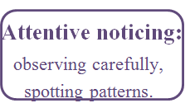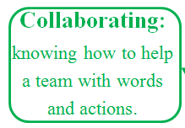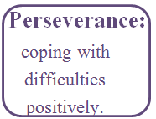A

These are the behaviours for learning that we teach and develop throughout Cirencester Primary School.