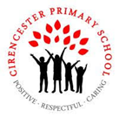

**Year 5 Autumn 1**

**Big question and our enquiries**

What makes

things move?

In Year 5, our Science lessons will be the main driver to answering the big question ‘What makes things move?’. We will then be using this learning across a range of curriculum lessons to help us to design, describe, create and evaluate different contraptions involving movement and force.

**Science**

**Forces**

* L1: What stops us from flying?
* L2: What’s the difference between weight and mass?
* L3: What makes the best parachute?
* L4: What are the forces acting on trains and boats?
* L5: How does friction act on an object?
* **Space**
* L1: Is the Earth really flat? What about the Sun and Moon?
* L2: What other planets are in our Solar System?
* L3: How do the planets move?
* L4: Why does a spherical moon look like it changes shape?
* L5 – Doesn’t the Sun move across the sky during the day?

**RE**

* L1: What are Hindu ideas about the four aims of life?
* L2: How might the idea of ‘karma’ and reincarnation effect the way you might live your life?
* L3: Why might most Hindus choose be vegetarian and should others do the same?
* L4: In Which ways have Hindus made a difference to the world-wide community?
* L5 What are Samskaras?
* L6 How do Hindus celebrate Vivaha? (weddings)

**Computing**

**Online Safety:**

Understanding online reputation.

Recognising suspicious content/devices

**Systems and Searching**

L1: What is a computer system?

L2: What is the role of a computer system?

L3: How do I use a search engine?

L4: How do I select my results?

L5: How are search results ranked?

L6: How are searches influenced?

**DT- Moving Models**

* L1. Who is my customer and what do they want from my product?
* L2: Who are the key inventors, designers, engineers, manufacturers of ground breaking products that I can use for inspiration? Research product design
* L3: Why is making a prototype model important during the design stage?
* L4: What techniques do I need to make my model?
* L5: Why should I test and evaluate my product?

**PSHE**

* L1: Why is it important to include people?
* L2: What is peer pressure?
* L3: What can I do if a friendship gets hard?
* L4: What can I do if a friendship is not making me happy?
* L5: What is the media?
* L6: What is fact and what is fiction?

**Art**

LP1: What is tone?

LP2: How can we paint a tonal portrait with one colour?

**Our Class Books**

**Fortunately, the Milk** by Neil Gaiman

**5A**- Kick by Mitch Johnson

**5B**- The boy at the back of the class by Onjali Q. Rauf

                     

**Our Outcomes**

By investigating our **Big Question** using our enquiry questions we will have:

* Carried out a wide range of forces experiments, testing theories and recording our results
* Designed cracking contraptions and created ‘how to’ information to go alongside
* Become Journalists through our Newswise project
* Designed and built working moving models linked to our class text **‘Fortunately, The Milk’**

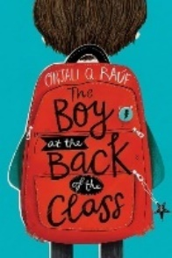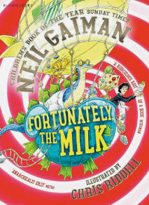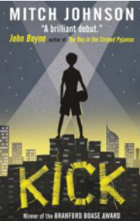

**Taught discretely (not part of our Big Question this term)**

Maths PE **Swimming and Tag Rugby** MfL – La Famille Music- **Singing**

|  |
| --- |
|  |

**Our Termly Values** Having a sense of belonging / Happiness & friendship