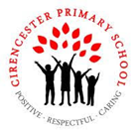

**How did Anglo-Saxon**

**settlers change Britain?**

**Year 5 Autumn 2**

**Big question and our enquiries**

In Year 5, our History lessons will be the main driver for our term. We will be exploring the true history of the community often referred as Anglo Saxons. By using the story of a family of the time, we will develop our understanding of how Germanic people migrated to Britain and changed dynamics of the country after the Roman invasion.

**History**

**Anglo-Saxon settlement**

L1: What were homes like in 400CE?

L2: Who lived in Britain in 400 CE?

L3: Why did the Anglo-Saxons come to Britain?

L4: What were early Anglo-Saxon villages like?

L5: How did Anglo-Saxons choose their leaders?

L5: What were the artistic achievements of the Anglo-Saxons?

L6: What can Sutton Hoo tell us about early kings?

**Science**

**Materials**

**L1:** What are the properties of solids, liquids and gases?

**L2:** How can I describe the properties of materials?

**L3:** Which materials make the best thermal insulators?

**L4:** Which materials are magnetic?

**Computing**

**Creating Media - Vector Drawing**

L1: What are drawing tools?

L2: How can I combine shapes?

L3: What makes an effective drawing?

L4: What are layers?

L5: How do you manipulate objects?

L6: What can you create?

**RE**

Christianity- Why might Christians believe Jesus was the Messiah?

L1: How do Christians put their beliefs about Jesus’ incarnation into practice at Christmas?

L2: Why is the Christingle an important symbol?

L3: What Gospel and prophecy texts refer to the Incarnation of Jesus?

L4: Why do Christians believe the world needs a ‘saviour’?

L5: Do you think the world needs a saviour? Why/why not?

**PSHE**

**L1:** What is equality?

**L2:** What is discrimination?

**L3:** What is a stereotype of a community?

**L4:** What is the impact of discrimination?

**L5:** How can I challenge discrimination safely?

**Art**

L1: How can a 3D object be captured on a flat sheet of paper?

L2: How is shape and form created in paintings?

**Our Outcomes**

By investigating our **Big Question** using our enquiry questions we will:

* Write a diary from the perspective of an Anglo-Saxon child
* Create fact files about the different elements of Anglo-Saxon life
* Participate in drama and enrichment activities to help us live a day in the life of an Anglo-Saxon
* Created replica artefacts from the Anglo-Saxon era

**Our Class Books**

**Anglo Saxon Boy by Tony Bradman**

**5A**- Kick by Mitch Johnson

**5B**- The boy at the back of the class by Onjali Q. Rauf

                     

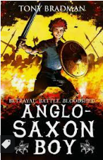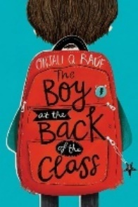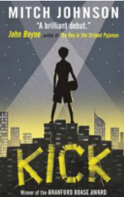

**Taught discretely (not part of our Big Question this term)**

Maths PE **Swimming and Netball** MfL – **Chez Moi** Music- **Singing**

|  |
| --- |
|  |

**Our Termly Values** Respect