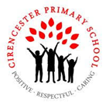

**Year 5 Spring 1**

**Big question and our enquiries**

**What is life like in Brazil?**

In Year 5, we will be exploring the vibrant and wildly varied districts and eco-systems of Brazil. We will be learning more about climate zones and comparing different areas of Brazil to the UK. We will explore the culture of Brazil through our music, art and geography learning, whilst jumping into the middle of the Amazon Rainforest through our focus reading text.

**Geography**

**Non-European case Study: Brazil**

L1: Where is Brazil?

L2: What are the physical features of Brazil?

L3: What is the climate like in Brazil, and why?

LP4: What could we experience in Rio?

LP5: What is it like living in Barra Di Tijuca?

LP6: What is it like living in Rochinha favela?

LP7: Why is Rio growing?

**Science**

**Materials- Reversible and Irreversible Changes**

L1: Which materials are soluble and which are insoluble?

L2: How can mixed materials be separated?

L3: What is irreversible change?

**Computing**

**Flat file databases**

L1: How can we record information?

L2: What is a database?

L3: How can we use databases?

L4: What tools can I use?

L5: How can I use a computer program to compare?

L6: How do I use databases to answer questions?

**RE**

**Islam- What does it mean to be a Muslim in Britain today?**

L1 What can we remember about Islam?

L2 What guides Muslim living?

L3: What is the design of a mosque?

L4: What are the different Muslim groups, globally and locally?

L5: What might be the challenge of Muslims following the five pillars in Modern Britain?

**PSHE**

L1: What are resources and how are they shared?

L2: What can we do to protect the environment?

L3: How can we encourage others to look after the planet?

L4: What do I think is important?

**PSHE/Computing- online safety** I can demonstrate how to make responsible choices.

**Art**

LP1: How does the culture and environment in Brazil influence its artists?

LP2: How can I create a piece of art that reflects my knowledge of the Brazilian culture and landscape?

**Our Outcomes**

By investigating our **Big Question** using our enquiry questions we will:

* Artwork inspired by Brazilian artist Beatriz Milhazes.
* Explore climates, eco-systems and renewable energy to help improve and protect the environment
* Write adventure stories inspired by our class text and the mystery of Percy Fawcett (missing Amazon explorer)
* Investigate the effects of deforestation in the Amzon rainforest and write persuasive letters

**Our Class Books**

**The Explorer by Katherine Rundell**

**5A**- Kick by Mitch Johnson

**5B**- The boy at the back of the class by Onjali Q. Rauf

                     

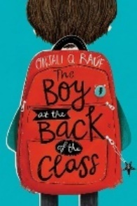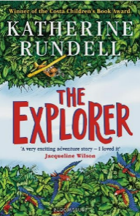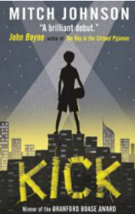

**Taught discretely (not part of our Big Question this term)**

Maths PE **Swimming** **Net and Wall games** MfL –**At school** Music- **Composers**

|  |
| --- |
|  |

**Our Termly Values** Respect Truthfulness