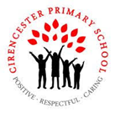

**Year 5 Spring 2**

**Big question and our enquiries**

**When and why did**

**people stop believing**

**in witchcraft??**

In Year 5, we will be exploring the truth behind why people stopped being tried for crimes involving witchcraft during the Stuart era in history. They explore a range of different sources that demonstrate the injustice that was inflicted upon so many, based upon their own superstitions.

**History**

L1: What was life like in Stuart England?

L2: What did people in Stuart England believe about witchcraft?

L3: How were witches supposed to be prosecuted in Stuart England?

LP4: What happened in Manningtree in 1645?

LP5: Why did people stop putting witches on trial?

LP6: When did people stop believing in witchcraft?

LP7:?

**Science**

**Materials- Reversible and Irreversible Changes**

L1: Which materials are soluble and which are insoluble?

L2: How can mixed materials be separated?

L3: What is irreversible change?

**Computing**

Coding for Climate Change- Microbit project

L0: What is a microbit?

L1: Define the problem

L2: Analysing existing solutions

L3: Build an early Warning System

L4: Introducing sensors

L5: Researching pins

L6: Researching radios

L7: Earthquake Early Warning System

**RE**

**Christianity - What do Christians believe Jesus did to ‘save’ people?**

L1 What account does Mark 14-15 give of Holy week?

L2 How does art work portray the scenes given by Mark?

L3: Who was responsible for Jesus’ death?

L4: How do Christians respond to the idea that Jesus sacrificed his own life for the sake of humans?

L5: How do different Christian churches?

**PSHE**

L1: What is ambition?

L2: What is a career?

L3: What is diversity in the workplace?

L4: How can my education help with my career?

**PSHE/Computing- online safety** Online safety and NSPCC, how to keep safe

**Art**

L1: How have artists inspired magic and awe in architecture?

L2: How can I invent a magical setting?

L3: Create a design from printing inspired by Gaudi?

**Our Outcomes**

By investigating our **Big Question** using our enquiry questions we will:

* Create an art piece demonstrating our own thoughts and beliefs on magic
* Explore the story of Manningtree and produce drama pieces
* Become a member of a jury and decide the fate of the suspects
* Take on a role in a court

**Our Class Books**

**The Explorer by Katherine Rundell**

**5A**- Kick by Mitch Johnson

**5B**- The boy at the back of the class by Onjali Q. Rauf

                     

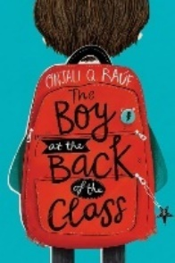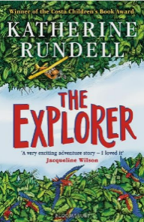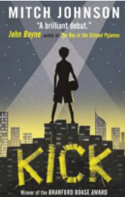

**Taught discretely (not part of our Big Question this term)**

Maths PE **Gymnastics & Quiksticks** MfL –**Weather** Music- **Pentatonic scale**

|  |
| --- |
|  |

**Our Termly Values: Personal responsibility**