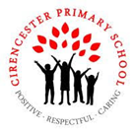

**Year 5 Summer 1**

**Big question and our enquiries**

**How was**

**England created?**

In Year 5, we will be continuing our history journey and building upon our knowledge of the Anglo Saxons and finding out more about the invasion of the Vikings.

**History**

**Viking and Anglo-Saxon conflict**

L1: Who lived in Britain in 750CE?

L2: How was England divided in 750CE?

L3: Why did the Vikings attack Britain?

L4: How did Alfred defend Wessex?

L5: How was England united?

L6: What did the Vikings contribute to English life?

L7: Who lived in England in 950CE?

**Geography Maps / Place names**

LP1: What Anglo-Saxon place names can I find around Gloucestershire?

LP2: What is the origin of place names in Lincolnshire?

**Science**

**Reproduction (sexual and asexual)**

L1: What are the seven life processes?

L2: How do mammals reproduce?

L3: Do animals reproduce in the same way?

L4: How do plants reproduce?

L5: What is a life cycle?

L6: What are the stages in a life cycle of a plant?

**Computing**

L1: What is a video?

L2: How do I record on a digital device?

L3: How does a storyboard support me?

L4: How do I plan my video?

L5: How can I improve a video?

L6: What can improve the quality?

**RE** Judaism- Why is the Torah so important to Jewish people? (U2.8)

L1: How is the Sefer Torah produced?

L2: How is the Sefer Torah used in the synagogue and in annual readings?

L3: How do the Mitzvot guide Jewish people?

L4: What are kosher food laws and how do they affect everyday life?

L5: Why are there different ways of behaving and worshipping within one religion?

L6: How do different Jewish groups practice their belief? (orthodox and progressive)

**PSHE** Health and Wellbeing

L1: Why do we need to sleep?

L2: How can I enjoy the sun?

L3: What is an allergy?

L4: What are vaccinations for?

L5: Why do we need to wash our hands?

L6: How can I keep safe?

**DT**

L1: What elements of the Eatwell plate would be included in a Viking and Anglo Saxon Diet - check to see this has not been completed in science

L2: What nutritional benefit would a Viking and Anglo Saxon diet have?

**Art**

LP1: What can we learn from Picasso?

LP2: How can I create a still life on a black background?

**Our Outcomes**

By investigating our **Big Question** using our enquiry questions we will:

* Biographies of prominent characters in the Battle of Hastings
* Balanced argument linked to the Batlle of Hastings
* Create a Viking meal in Forest School

**Our Class Books**

**The Explorer by Katherine Rundell**

**5A**- Kick by Mitch Johnson

**5B**- The boy at the back of the class by Onjali Q. Rauf

                     

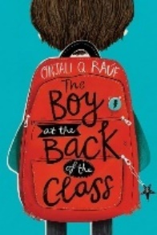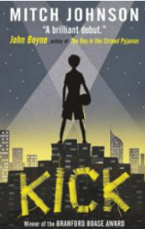

**Taught discretely (not part of our Big Question this term)**

**Maths** **PE** Games / Athletics **MfL –** At the tearooms –**Music**-Theory

|  |
| --- |
|  |

**Our Termly Values:**